In this article you will learn about how to store html form data to Microsoft Excel using VB script.

Step 1:

1. Start the Excel application
2. Create Header label text for each column look as following diagram

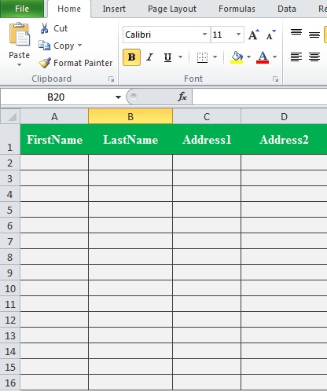

Figure 1: Data Column Header

1. Save the Workbook with file extension **“xlsx”**
2. Open the notepad
3. Add the code line shown below.

<! DOCTYPE html>

<Html>

<Head>

<script language="vbscript" type="text/vbscript">

Sub Sample ()

Dim iRow

Set objExcel = CreateObject ("Excel. Application")

Set objWorkbook = objExcel.Workbooks.Open ("C:\Users\Karthikeyan.K\Desktop\Book1.xlsx")

objExcel.Application.Visible = True

ObjWorkbook.Windows (1).Visible = True

Set XlSheet =objWorkbook.Sheets (1)

XlSheet.Activate

iRow = 1

With objExcel

Do while .Cells (iRow, 1).value <> ""

.Cells (iRow, 1).activate

iRow = iRow + 1

Loop

.Cells (iRow, 1).value=Document.GetElementsByName ("fname") (0).Value

.Cells (iRow, 2).value=Document.GetElementsByName ("lname") (0).Value

.Cells (iRow, 3).value=Document.GetElementsByName ("Add1") (0).Value

.Cells (iRow, 4).value=Document.GetElementsByName ("Add2") (0).Value

MsgBox "Data Added Successfully”, vbinformation

Document.GetElementsByName ("fname") (0).Value=""

Document.GetElementsByName ("lname") (0).Value=""

Document.GetElementsByName ("Add1") (0).Value=""

Document.GetElementsByName ("Add2") (0).Value=""

End With

ObjWorkbook. Save

ObjWorkbook. Close

Set objWorkbook = Nothing

Set objExcel = Nothing

End Sub

</script>

<style type="text/css">

fieldset {

border: #00cc00 2px solid;

padding: 10px;

color: green;

</style>

<body

<form>

<fieldset>

<legend>Csharpcorner</legend>

<center>

<img src="C:\Users\Karthikeyan.K\Desktop\Add-Male-User.png" alt="Mountain View"><br>

First name:<br>

<input type="text" name="fname" Value=""><br>

Last name :< br>

<input type="text" name="lname" Value=""><br>

Address1 :< br>

<input type="text" name="Add1" Value=""><br>

Address2 :< br>

<input type="text" name="Add2" Value=""><br>

<br>

<input type="button" onclick="Sample()" value="Submit" /><br>

</center>

</fieldset>

<form>

</body>

</html>

1. Save the file with extension **“.htm”**

Step 2:

Follow the steps to turn on or turn off VBScript in your Internet Explorer:

1. Choose **Internet Options** from the **Tools** menu

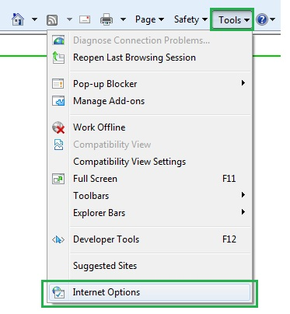

1. Select Security tab from the dialog box
2. Click the Custom Level button

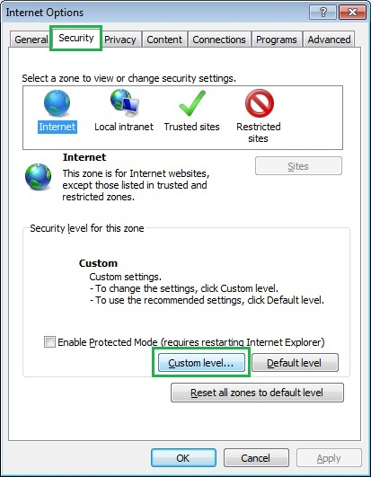

1. Scroll down till you find Scripting option

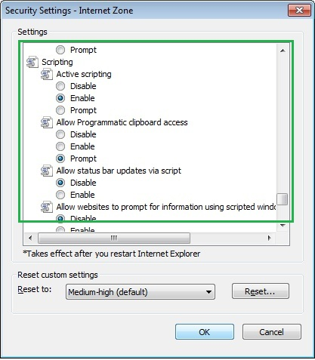

1. Select Enable radio button under Active scripting
2. Finally click OK and come out

Output:

1. Open the html document

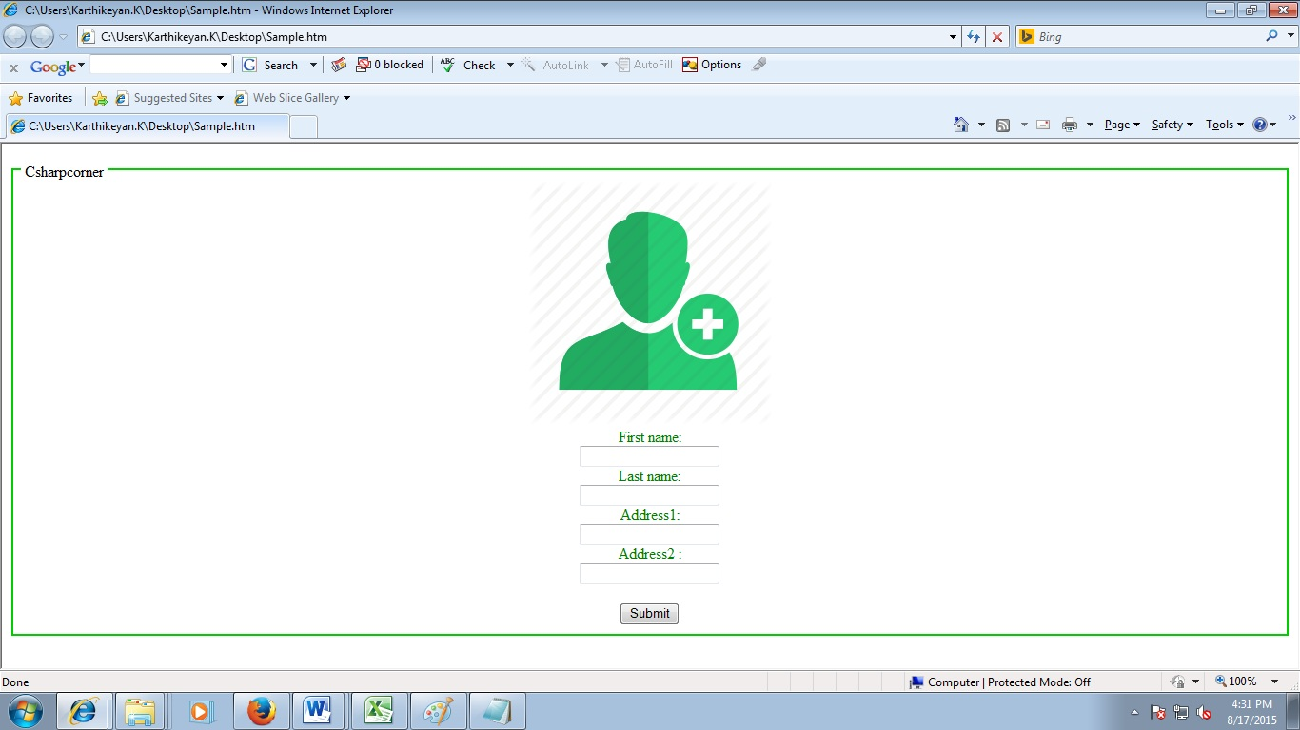

Figure 2: User Input Form

1. Enter the data then press the submit button

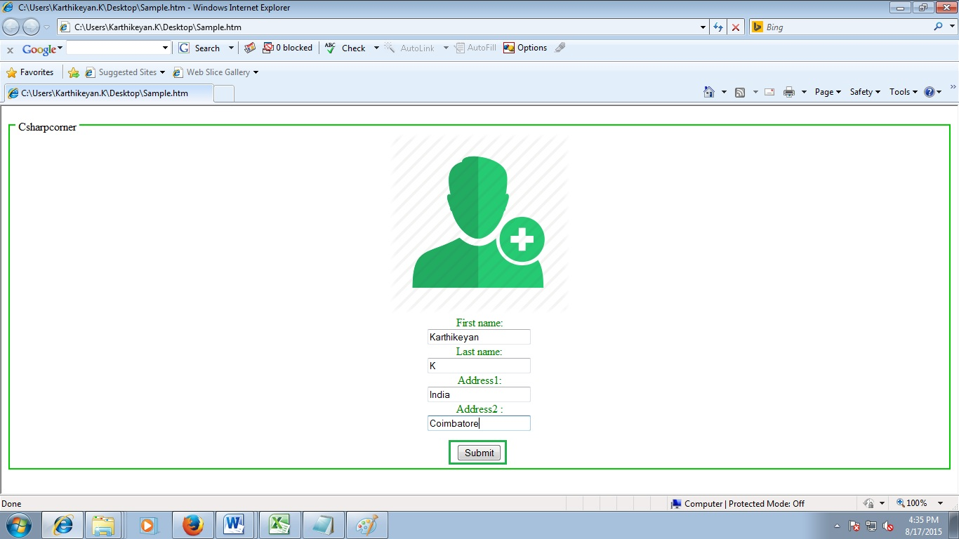

Figure 3: User input data

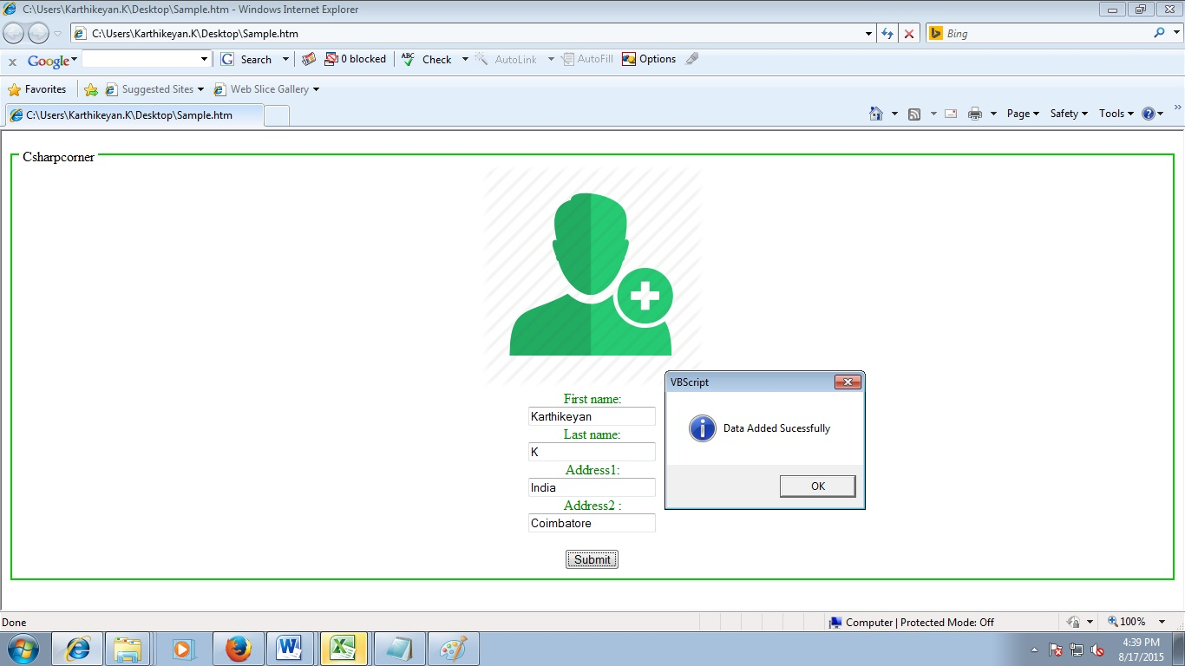

Figure 4: Data added successfully

1. Open the Workbook to check sheet1 data’s

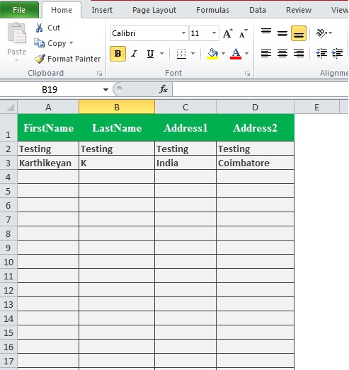

Figure 5: User data sheet

Conclusion:

Thanks for reading..! I hope you liked this article: Please provide your valuable suggestions.

Have a Nice Day